Decrease “BAD” Cholesterol (LDL)
How can I decrease my “bad” cholesterol (LDL) level?___________________________________________________
- If you have high cholesterol, it may be necessary for you to make some changes in your life.
- If you smoke, quit.
- Exercise regularly. If you haven't been exercising, try to work up to 30 minutes, 4 to 6 times a week.
- If you're overweight, losing just 5 to 10 pounds can help reduce your cholesterol levels.
- Make sure to eat a heart healthy diet (see below)-fruits, vegetables, whole grains and fish.
- Avoid foods with saturated and trans-fats, which can raise cholesterol levels.
- Limit your overall cholesterol intake to less than 300 milligrams per day and 200 milligrams if you have heart disease.
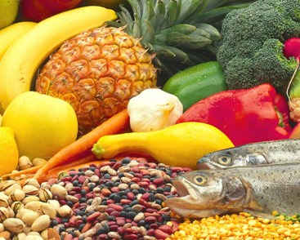
- Depending on your risk factors, if healthy eating and exercise don't work to lower your cholesterol level, your doctor may suggest medication to reduce your cholesterol level.

Eating a heart-healthy diet!_______________________________________
- Eat plenty of fresh fruits and vegetables, they are naturally low in fat. They are also the best source of fiber, vitamins and minerals for your body. Aim for 5 cups of fruits and vegetables every day.
- Pick “good” fats over the “bad” fats. Fat is part of a healthy diet, but you need to know the difference between “bad” fats and “good” fats.
- "Bad” fats, such as saturated and trans fats, are found in foods such as butter; coconut and palm oil; shortening and margarine; animal fats in meats; and fats in whole milk dairy products. Limit the amount of saturated fat in your diet, and avoid trans fat completely.
- “Good” fats, such as unsaturated fats are found in most fish, vegetables, grains and tree nuts. Try to eat unsaturated fat in place of saturated fat. For example, you can use olive oil or canola oil in cooking instead of butter.
- Use healthier cooking methods. Baking, broiling and roasting are the healthiest ways to prepare meat, poultry and other foods. Trim any outside fat or skin before cooking. Use either a nonstick pan or nonstick cooking spray instead of adding fats such as butter or margarine. When eating out avoid fried foods.
- Look for sources of protein in fish, dry beans, tree nuts, peas which offer protein, nutrients and fiber without the cholesterol and saturated fats that meats have.
- Get more fiber in your diet. Add good sources of fiber to your meals. Examples include fruits, vegetables, whole grains (such as oat bran, whole and rolled oats and barley), legumes (such as beans and peas) and nuts and seeds (such as ground flax seed).
- Eat more fish. Fish are an excellent source of omega-3 fatty acids. Fish, such as salmon, tuna, mackerel and sardines, are the best sources of omega-3s, but all fish contain some amount of this beneficial fatty acid. Aim for 2 6-oz servings each week.
- Limit how much cholesterol you get in your diet. You should limit your overall cholesterol intake to less than 300 milligrams per day, or less than 200 milligrams if you have heart disease.
- If you have heart disease or high triglycerides, consider taking an omega-3 or fish oil supplement. Make sure the supplement has at least 1,000 mg of EPA and DHA (these are the specific omega-3 fatty acids found in fish).
- Red yeast rice. A common seasoning in Asian countries, red yeast rice may help reduce the amount of cholesterol your body makes. It is available as a dietary supplement. Talk to your doctor before taking red yeast rice, especially if you take another cholesterol-lowering medicine called a statin. The recommended dose of red yeast rice is 1,200 milligrams twice a day.

