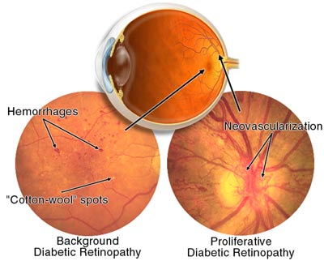
Why is it important to prevent and treat diabetes?
Diabetes: Eye Care

Untreated diabetes causes blood sugar levels to rise. This can lead to a number of serious problems, including: Eye Damage that can cause blindness.

Diabetic Retinopathy (eye problems)
The retina is the part of the eye that is sensitive to light and sends messages to your brain about what you see. Diabetes can damage and weaken the small blood vessels in the retina. This damage is called diabetic retinopathy.
When the blood vessels of your retina are damaged, fluid can leak from them and cause swelling in your macula. The macula is the central part of the retina and give you sharp, clear vision. The swelling and fluid can cause blurry vision and make it hard for you to see. If retinopathy gets worse, it may lead to blindness.
Laser surgery can often be used to treat or slow down retinopathy, especially if the problem is found early. People who have diabetes should have an eye exam once a year.

Warning signs of eye problems

- Blurry vision for more than 2 days
- Sudden loss of vision in 1 or both eyes
- Black or gray spots, cobwebs or strings that move or drift when you move your eyes (called floaters)
- Flashing lights in your vision that aren't really there
- Pain or pressure in your eye(s)

What can I do to prevent or delay diabetic complications?

- Carefully follow your doctor's instructions for taking your insulin.
- Eat a variety of healthy foods. Avoid foods that are high in fat, cholesterol, salt and added sugar.
- Maintain a healthy weight. If you're overweight, your doctor can give you advice on how to lose weight safely.
- Keep your blood pressure at a healthy level (below 130/80 mm Hg).
- Maintain a healthy cholesterol level (under 200 mg).
- Be physically active on a regular basis.
- Quit smoking.
- Have an eye exam every year to check your vision.
- Stay up-to-date on your immunizations. Get a flu shot each year and a tetanus booster every 10 years.
- Manage your stress.
- See your doctor regularly, even when you feel fine. Your doctor will check for early signs of complications

