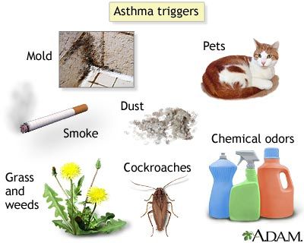  Avoiding triggers will improve your symptoms and decrease the numbers of attacks  Top 5 Common triggers  1-Tobacco smoke: Tobacco is unhealthy for everyone. Try to avoid cigarettes and second hand smoke  2-Dust mites: They are found everywhere. Remove stuffed animals and wash your beddings frequently in the hottest water setting  3- Pets: Keep pets outside as much as possible and bathe your pets once a week  4- Molds: Use dehumidifier, and fix water leaks  5- Others: Industrial smoke, physical exercise, allergies, infections (e.g. Flu).  Do not forget to take your Flu shot every year |  |  | Asthma Facts  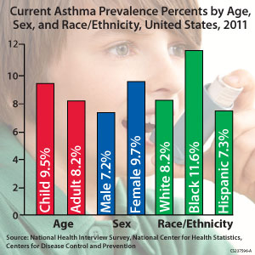  Signs of an Asthma Attack  - 1- Severe wheezing when breathing both in  - and out  - 2- Very rapid breathing  - 3- Chest pain or pressure  - 4- Difficulty talking  - 5- Feelings of anxiety or panic  - 6- Pale and sweaty face  - 7- Low peak flow reading under 50 % of  - personal best  - 8- Worsening symptoms despite using your  - rescue inhaler  - If you experience any of those symptoms immediately use your rescue inhaler. If no response after two doses CALL 911  - There are 18.9 million adults with asthma  - Asthma causes 1.2 million emergency ER visits  - There are 3400 deaths a year due to asthma attacks  - There is NO CURE for asthma  - Asthma is CONTROLLABLE |  |  | Asthma Patient Education Sheet  - Asthma is a disease that affect the lungs leading to breathing difficulty  Things to know about asthma  1-Asthma is the most common chronic  disease in children  2- Asthma can be controlled  3- An asthma attack can cause death if  untreated  4- There are triggers that causes asthma  attacks  5- Medications consists of rescue inhalers and management inhalers, which should only be used as directed  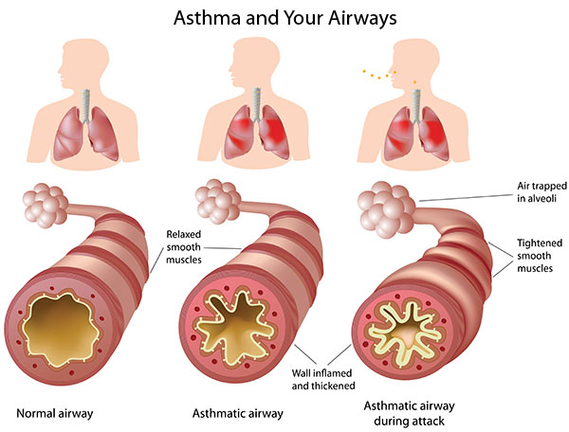  Asthma and COPD are both diseases of the lung that cause breathing difficulty. However COPD is chronic inflammation and destruction of the lungs that is mainly caused by SMOKING  IT IS NOT TOO LATE TO QUIT SMOKING  Ask us how to sign up for our FREE smoking cessation program

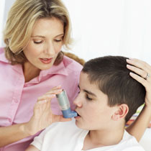  Treatment  - Recognize and avoid triggers  - Recognize signs of an asthma attack  - Avoid using your daily inhaler to treat an asthma attack  - Make sure that you know how to use an inhaler correctly  - Speak to your doctor if you are using your rescue inhaler more than twice a week  Different Types of Inhalers  - Metered Dose Inhaler  Examples include  Proair HFA, Proventil HFA, Ventolin HFA, Combivent.  Things to remember  - Prime the medications if needed  - Inhale slowly while taking a breath  - Hold breath for at least 10 seconds  - Dry Powder Inhalers  Examples are  Diskus, Handihaler, Pressair, Twishaler  Things to remember  - Inhale quickly and deeply  - Hold breath for at least 10 seconds |  |  | Questions?  If you have any questions about you asthma or how to use your medication you can  - Ask your doctor or your pharmacist  - Give us a call at the clinic  - Visit any pharmacy  - Refer to your medication sheet |  |  | 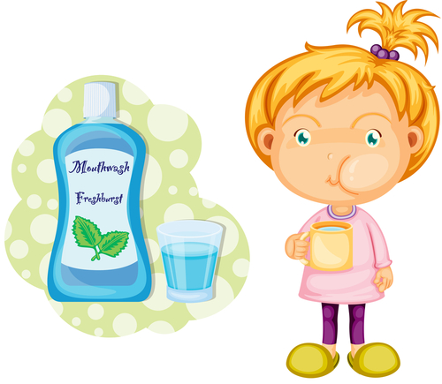  Rinse the mouth EVERY TIME after using the following inhalers  - Asmanex  - Flovent  - Symbicort  - Advair  - Dulera  - Azmacort  - Qvar  - Pulmicort  - Aerobid  Make sure you know how to use your inhaler correctly  - Do not use your daily medication as a rescue inhaler  - Call 911 if you have an asthma attack that does not respond to at least two doses of your rescue inhaler  References  http://trihealth.adam.com/graphics/images/en/23233.jpg  http://www.cdc.gov/asthma/images/237596A_FinalGraph.jpg  http://www.umm.edu/graphics/images/en/22934.jpg  http://www.auradentistry.com/wp-content/uploads/2010/09/pediatric-family-dentist-mclean-va-tysons-corner-22101.jpg  http://www.mayoclinic.com/health/asthma-attack/DS01068/DSECTION=symptoms

